**What is DynamoDB?**

Amazon DynamoDB is a **fully managed**, **proprietary** **NoSQL** Database service provided by Amazon under its AWS services portfolio. DynamoDB provides APIs allowing clients to query or make changes to the DynamoDB over the network.

DynamoDB doesn’t care whether the traffic is public, from an EC2, or through a VPC.

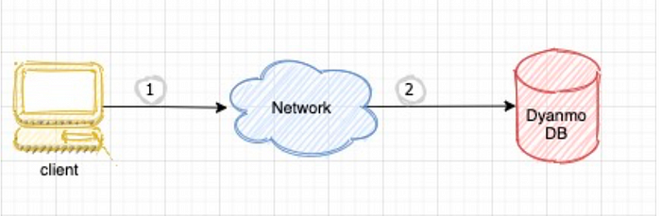

**When to use DynamoDB?**

1. No Analytics is required on the data
2. Data is significantly large and consistent SLAs are required
3. **Access patterns are known**we exactly know the fields that will be used to query the data right now and in the foreseeable future

*In relational DBMS, Data can be queried flexibly but queries are relatively expensive and also don’t scale well in high traffic situations. Whereas in the case of DynamoDB, data can be queried very efficiently but only in a limited number of ways.*

**When Not to use DynamoDB?**

1. Access patterns are not clear before designing
2. You need analytics-based queries

**DynamoDB vs Other NoSQL Database (MongoDB)**

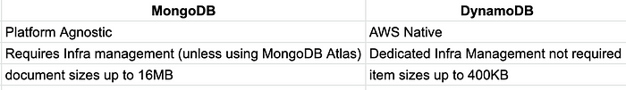

**Step 1:** Navigate to the **DynamoDB Dashboard** and click Create table.

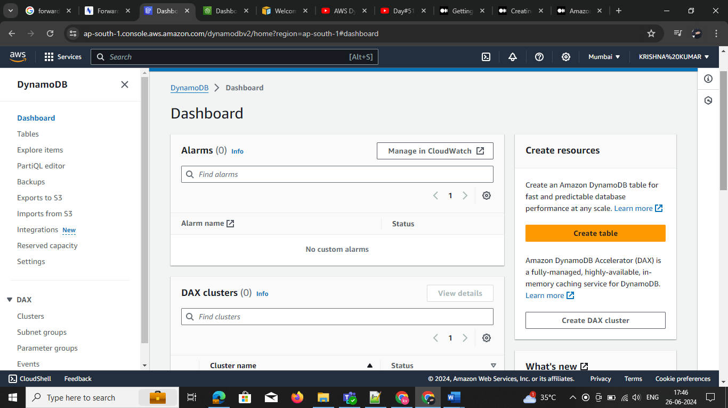

**Step2 :** give the name the table name 🡪 Partition key name and select type string ,number ,binary

Then click on create then emp is created

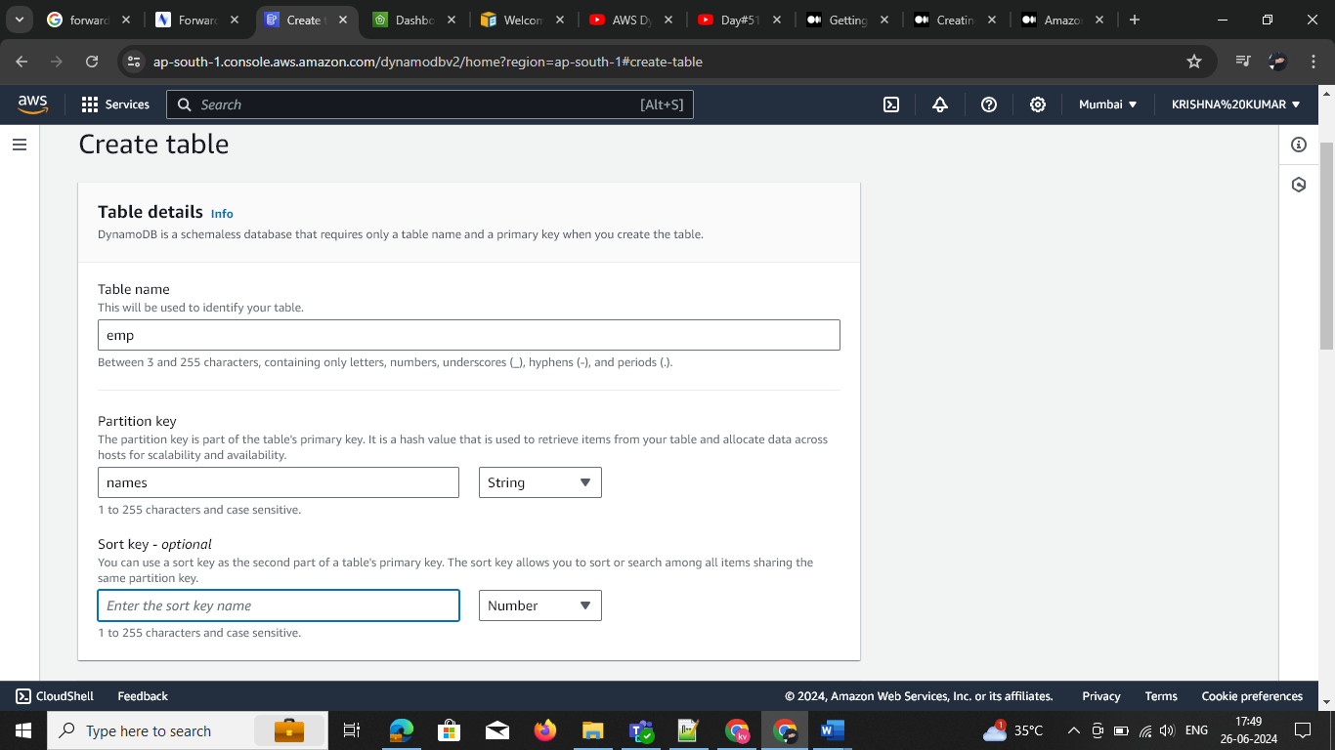

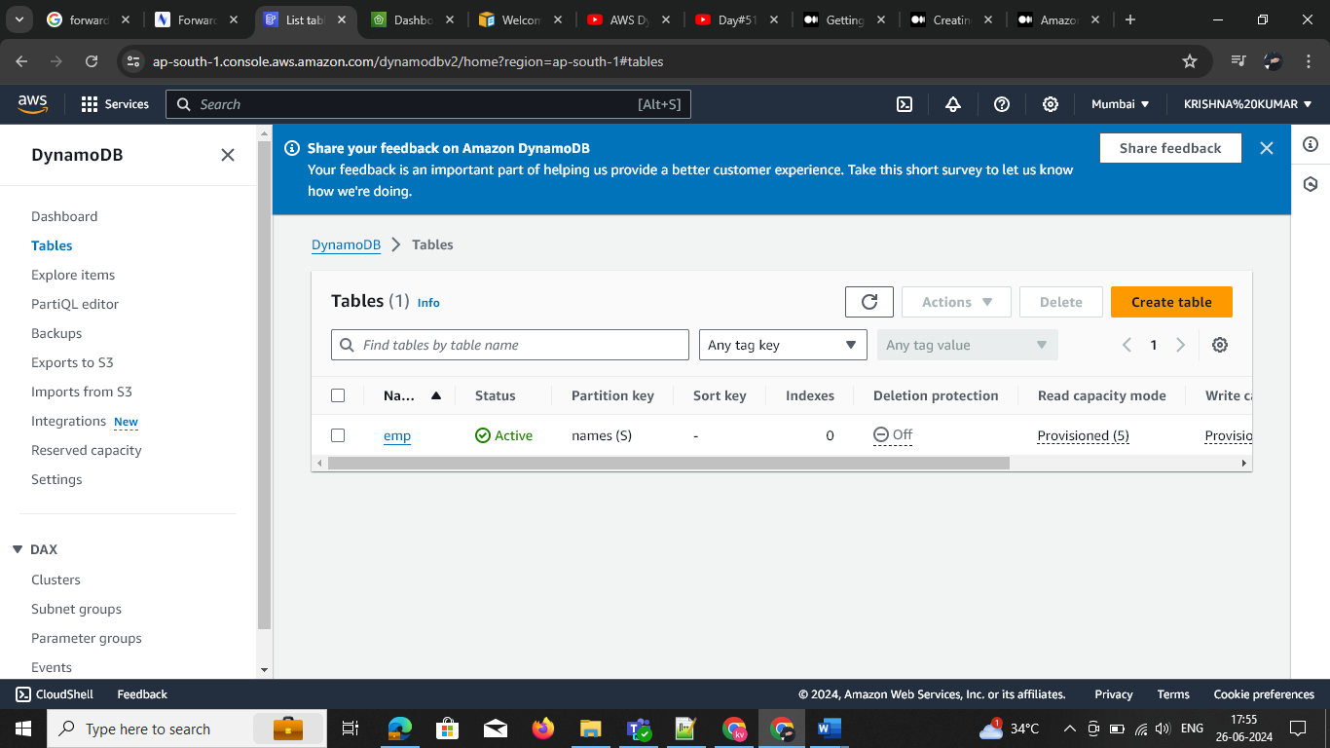

**Step 4: Emp** is created now we need to add the values -🡪 click create the table --🡪 select the any format JSON, form 🡪 click on create

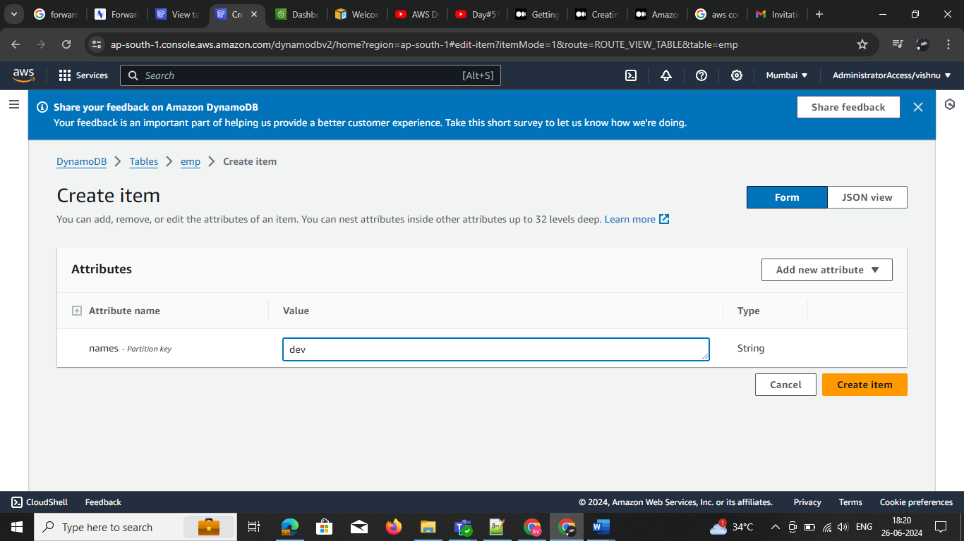

* Ones the compelete the table looks like this

